Part 1:



Part 2: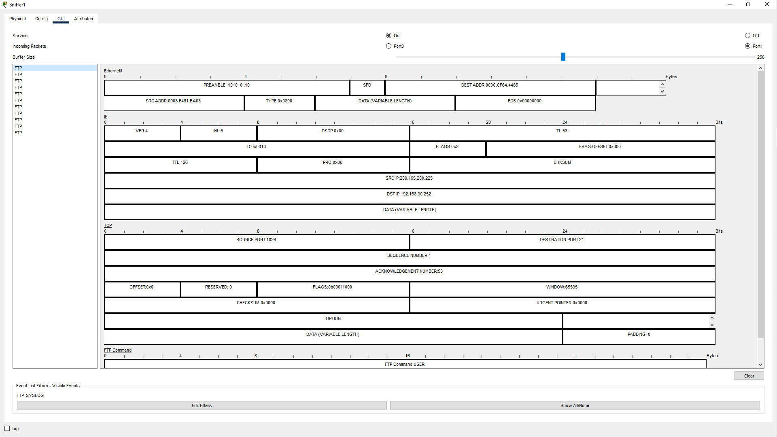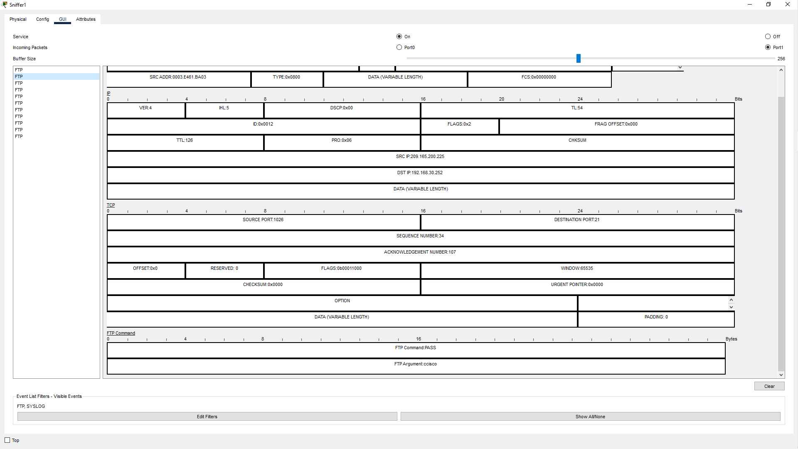

What is the security vulnerability presented by FTP?

Answer: Unencrypted FTP username and password, all actions are recorded.

What should be done to mitigate this vulnerability?

Answer: Use a secure file transfer protocol, encrypt information, perform operations

Part 3: